1)Install git.

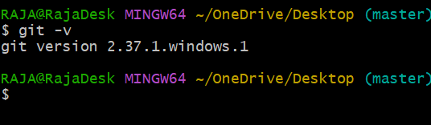

2)Create a repo in GitHub with README.md and. ignore file.

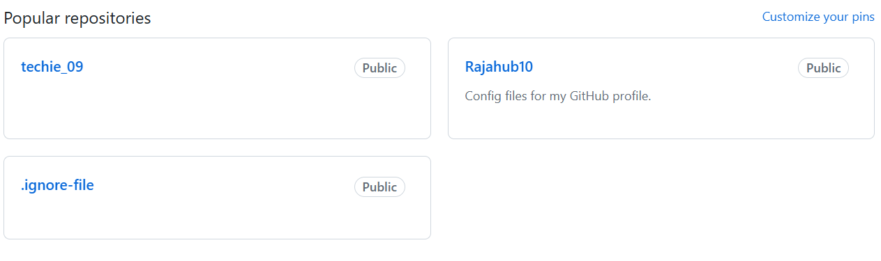

3)Clone the created repo to local.

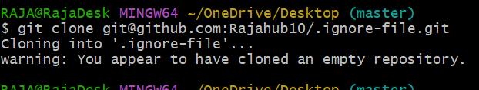

4)Create two files in local repo.

5)Commit two files and push to central Repository.

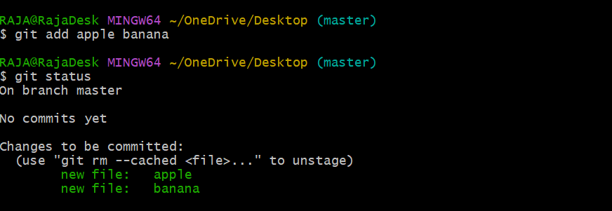

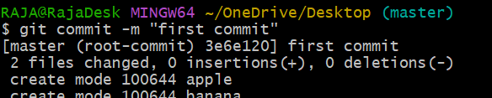



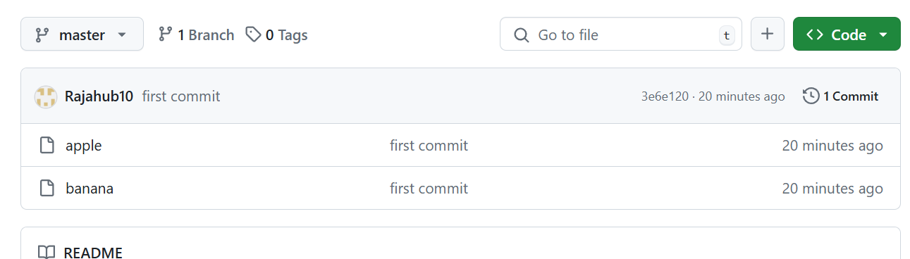

6)Create a branch in local and create a sample file and push to central.

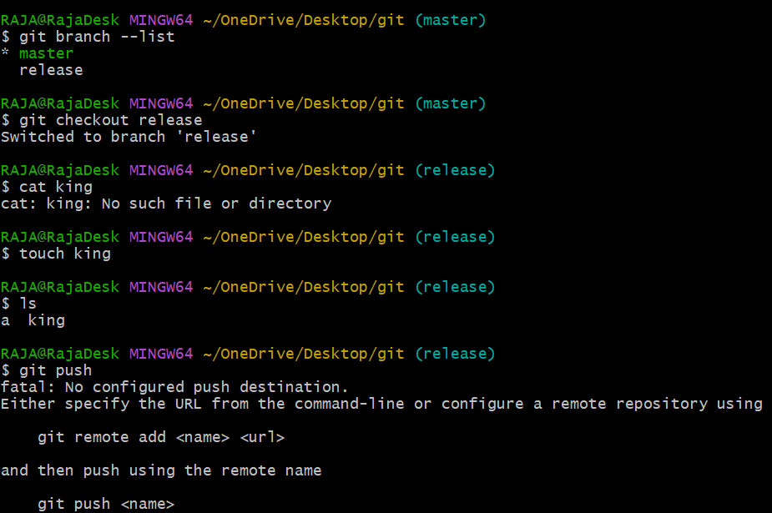

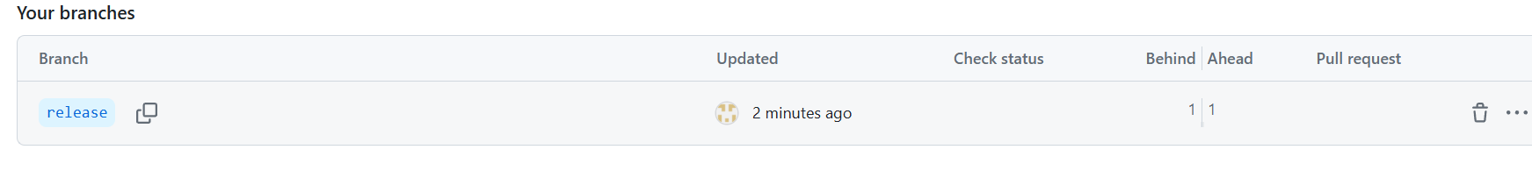

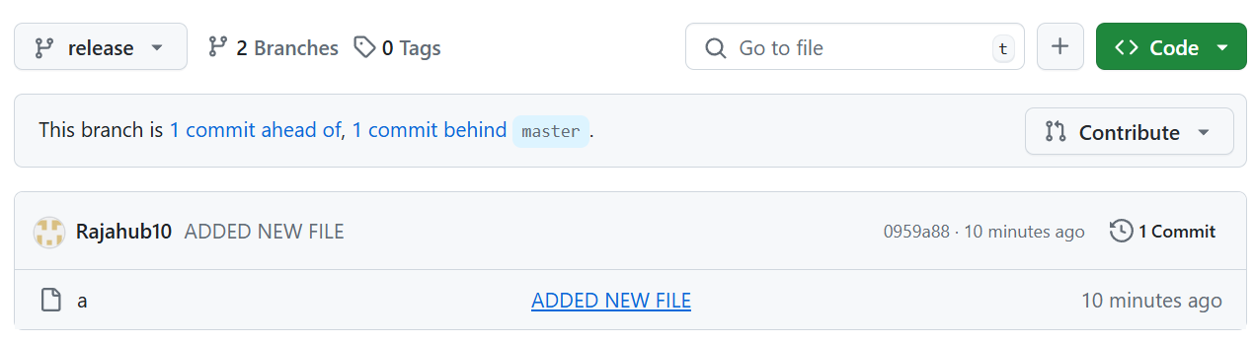

7)Create a branch in GitHub and clone that to local.

